**Raftwise Product Overview and Social Media Engagement**

**Introduction**

This document provides an overview of Raftwise products, a Linkedin automation and content creation tool, and details the approach taken to promote Raftwise on social media platforms such as Reddit, Quora and Twitter.

**Task 1: Understanding Raftwise Products**

Raftwise is an AI-powered tool designed to enhance linkedin engagement and streamline content creation. The platform offers a suite of features aimed at professionals and businesses looking to optimize their linkedin presence. Raftwise Provides following services with the help of free tools which they have provided on their website.

**Content Creation:** Raftwise helps to generate personalized and engaging content, including text posts and visual elements like carousels. Users can easily create eye-catching carousels with the **Linkedin Carousels Creator** and preview posts with the **Linkedin Post Preview Generator.**

**Features:** Post Scheduler, Content Helper, Idea Generator, Blog Post to Linkedin Post, Youtube Post to Linkedin Post, Twitter Post to Linkedin post.

**Automation :** The tools allow users to schedule posts for optimal times, ensuring maximum visibility and engagement without the need for daily manual posting.This feature helps maintain a consistent and active Linkedin Profile.

**Engagement :** Raftwise provides smart comment generation and post summaries to facilitate authentic and efficient interaction. Users can engage with new posts quickly, adding thoughtful comments that enhance their professional presence.

**Tools :** Raftwise offers various free tools such as:

**Linkedin video downloader :** It is a tool provided by the Raftwise that allows users to download videos from Linkedin for offline use.Users can easily download the videos from Linkedin directly, which can be useful for offline viewing, archiving and sharing on other platforms.

**How to use :** Users would need to copy the URL of the Linkedin video they want to download and paste it into the Linkedin video downloader tool and follow the prompt to download the video file on their devices.

**Linkedin Headline Generator :** It is a tool provided by the Raftwise designed to help users to create optimized headlines for their linkedin Profiles. This tool generates headlines suggestions based on user input, such as job title, skills and industry. It also ensures that headlines include relevant keywords to enhance searchability and visibility on linkedin.

**How to use :** Users input theri current job titles, key skills and industry into the tool. The generator then produced several headline options tailored to highlight their professional strength and attract attention.

**Linkedin Hook Generator** : It is a tool provided by the Raftwise that helps users to create engaging and compelling opening lines for their linkedin posts.These hooks are designed to capture attention quickly and encourage readers to engage with content, whether it's by continuing to read, like , comment or share. It also used AI to generate impactful opening lines based on the topic or content of the post and provide various hook options.

**How to use :** Users input a brief description of their post or its main topic in the tool. The generator then produces several hook options designed to draw new readers.

**Best time to post :**  It is a tool provided by the Raftwise that helps users to determine the ideal times to publish their linkedin content for maximum engagement. This tool analyzes user data and linkedin activity trends to suggest optimal posting times when followers are most active and likely to engage with posts.

**How to use :** User input their linked account details or upload follower activity data. The tool analyzes this information and suggests the best time to post content.

**Linkedin Carousel creator :** It is a tool provided by the Raftwise designed to help users to create visually engaging carousel posts for linkedin. Carousel posts can be used for storytelling, presentation or showcasing products and services.

**How to use :** Users can start from selecting templates or creating a carousel. They can then upload images, add text, and customize each slide. Once completed, the carousel can be previewed and downloaded for posting on LinkedIn.

**TASK 2 : Promoting Raftwise on Social Media Platforms Like Reddit, Quora, and Twitter.**

**Reddit**

* Comment -1

PostLink - <https://www.reddit.com/r/digital_marketing/comments/16w0gle/tips_to_optimize_your_linkedin_profile/?utm_source=share&utm_medium=web3x&utm_name=web3xcss&utm_term=1&utm_content=share_button>

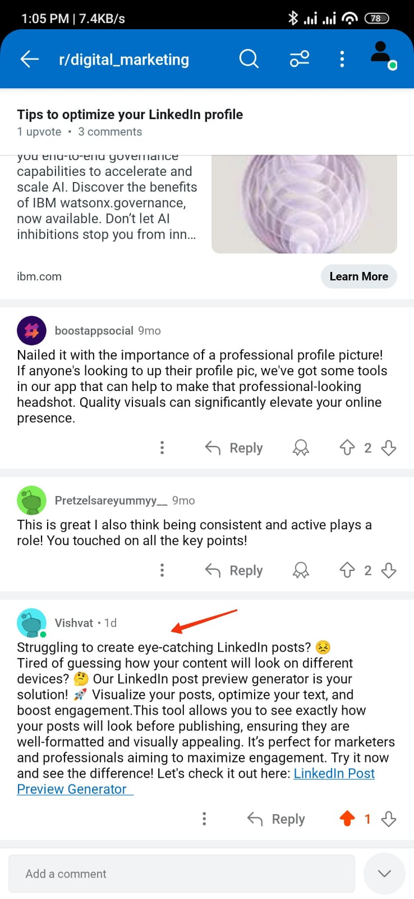

* Comment - 2

Postlink - <https://www.reddit.com/r/linkedin/comments/1e18vt4/best_time_to_post/?utm_source=share&utm_medium=web3x&utm_name=web3xcss&utm_term=1&utm_content=share_button>

* Comment - 3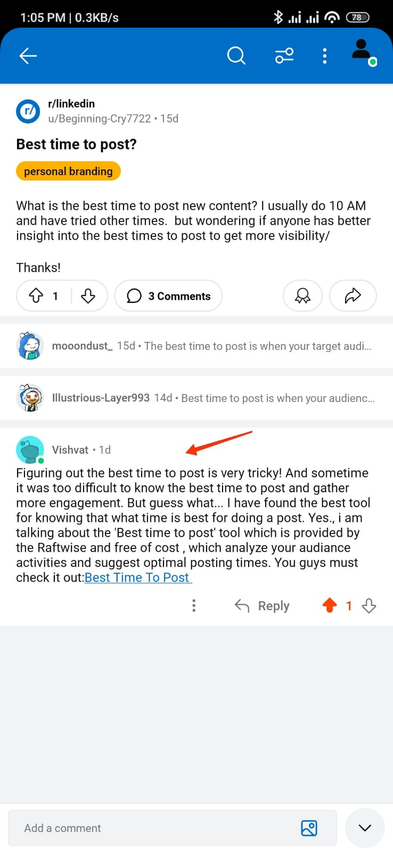

Postlink

<https://www.reddit.com/r/linkedin/comments/1ajpqtu/linkedin_engagement_is_just_weird/?utm_source=share&utm_medium=web3x&utm_name=web3xcss&utm_term=1&utm_content=share_button>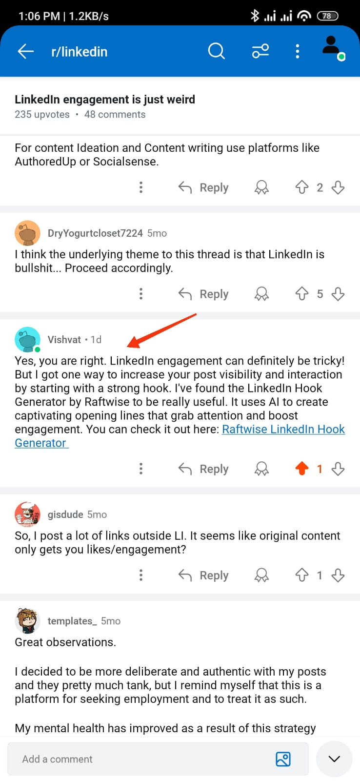

* Comment - 4

Postlink-<https://www.reddit.com/r/LinkedInLunatics/comments/1cuq62b/what_are_the_tips_of_optimizing_your_linkedin/?utm_source=share&utm_medium=web3x&utm_name=web3xcss&utm_term=1&utm_content=share_button>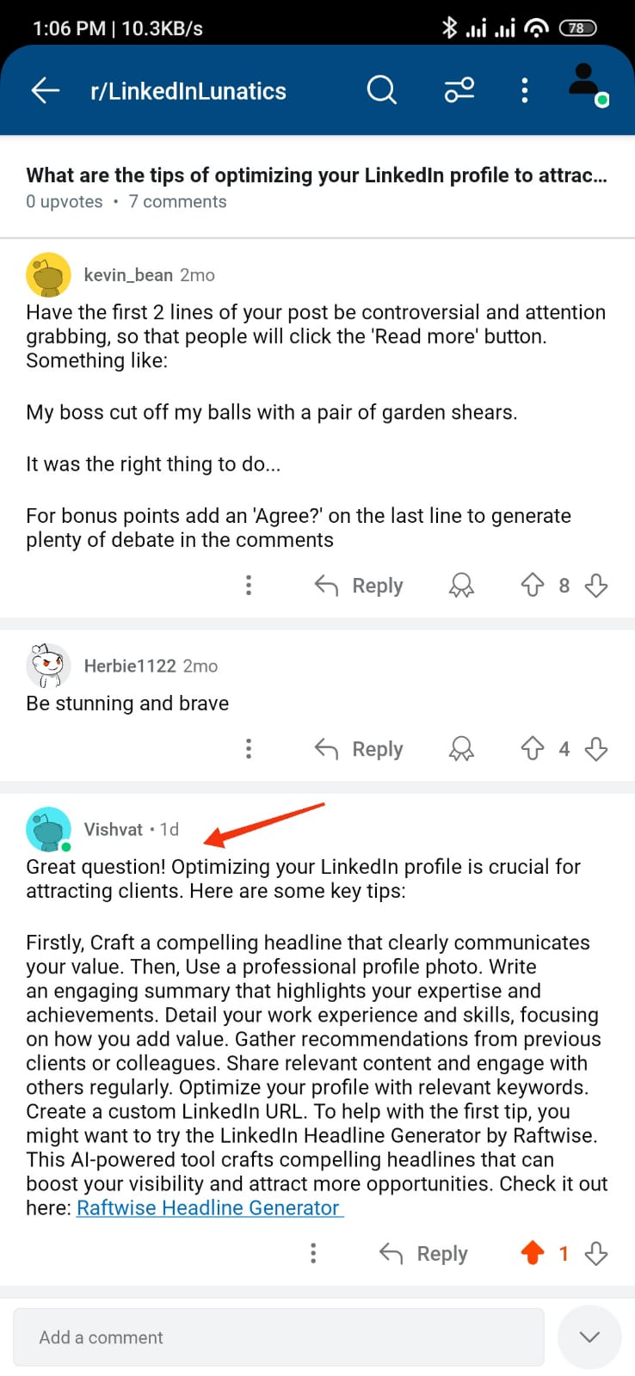

* Comment - 5

Postlink-

<https://www.reddit.com/r/shortcuts/comments/a8o8as/linkedin_video_download/?utm_source=share&utm_medium=web3x&utm_name=web3xcss&utm_term=1&utm_content=share_button>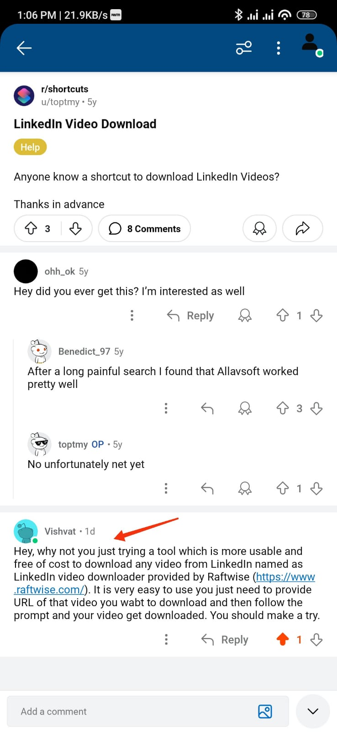

**Quora**

* Comment- 1 Comment- 2

Postlink- <https://qr.ae/p28lm8> Postlink-<https://qr.ae/p28ljp>

* Comment - 3 Comment - 4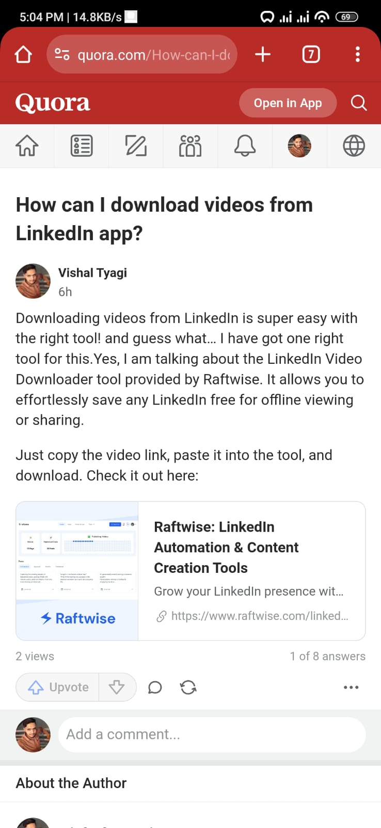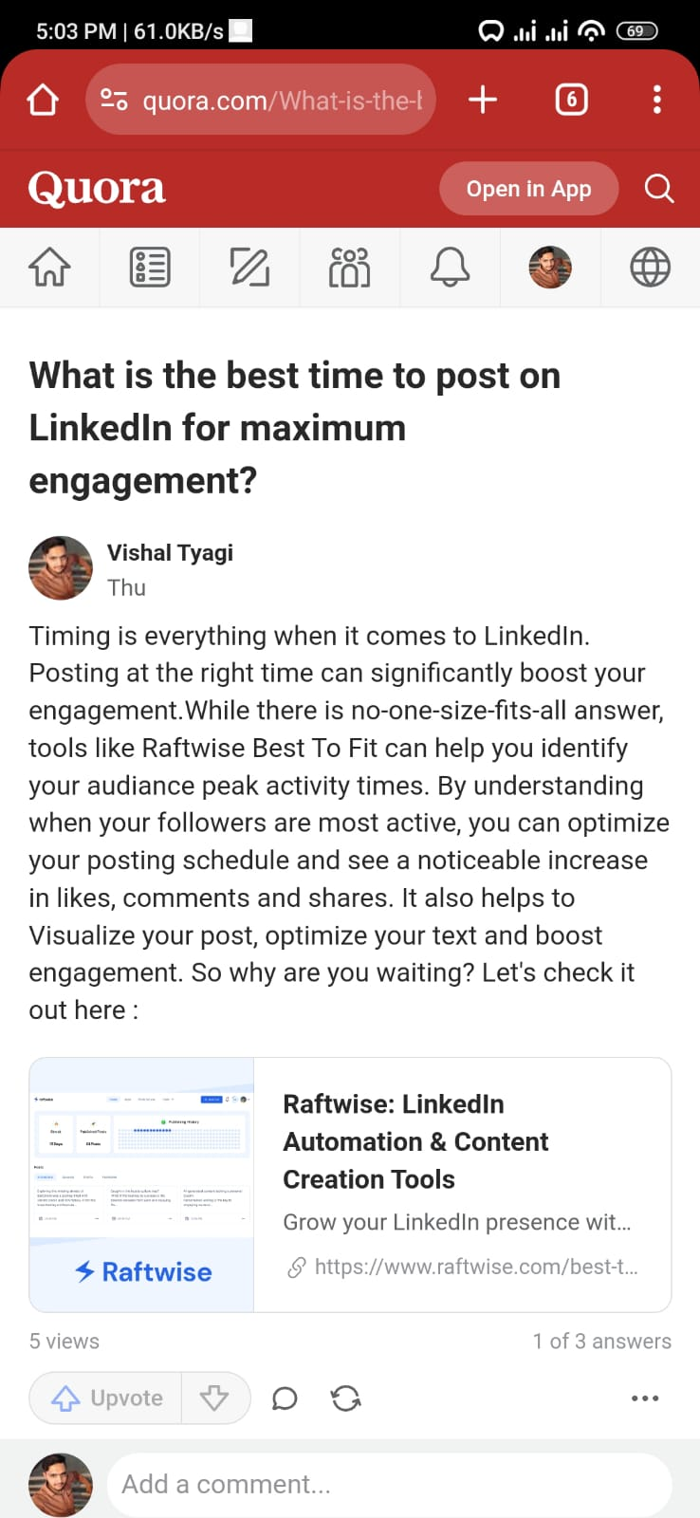

Postlink -<https://qr.ae/p28q8B> Postlink- <https://qr.ae/p28qpP> 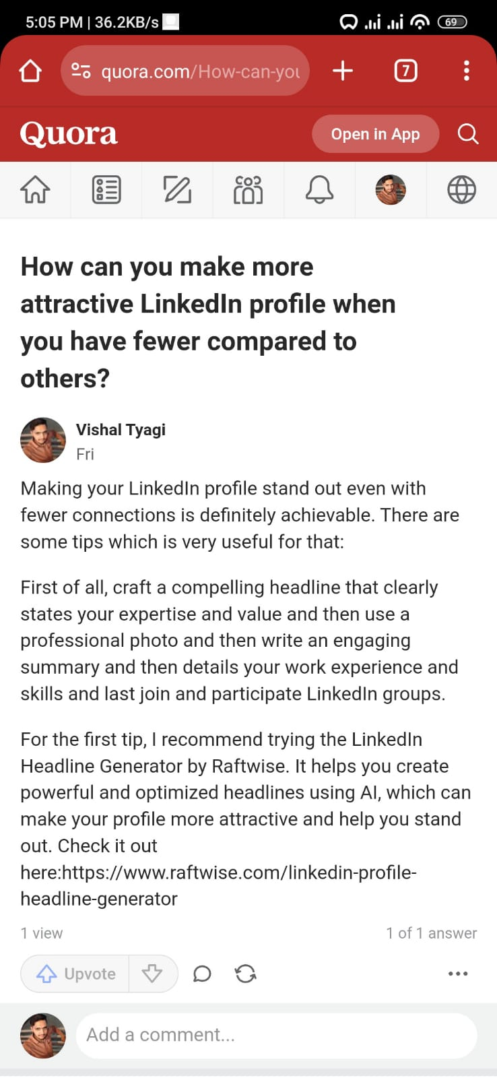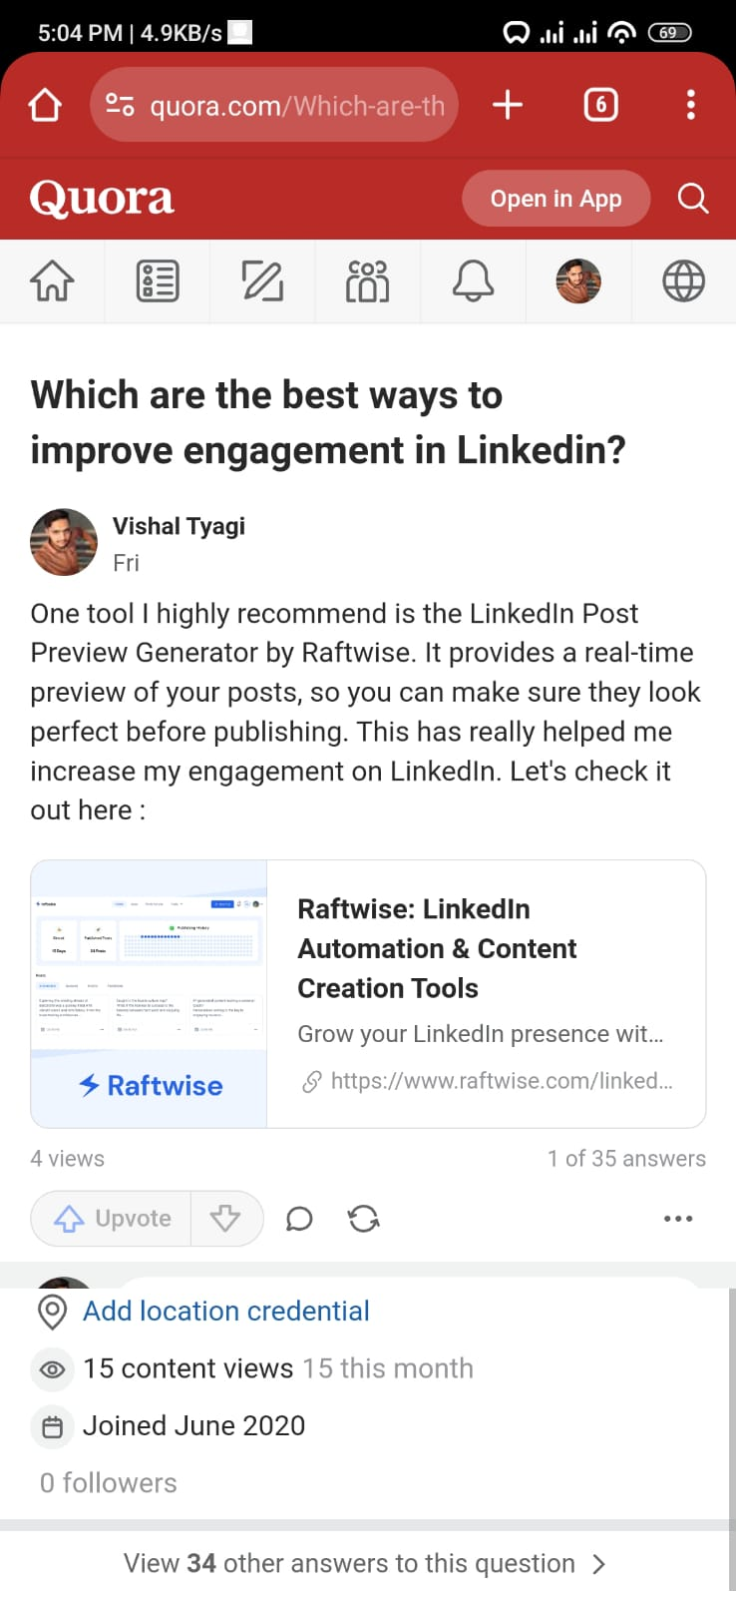

* Comment - 5

Postlink- <https://qr.ae/p28qKX>

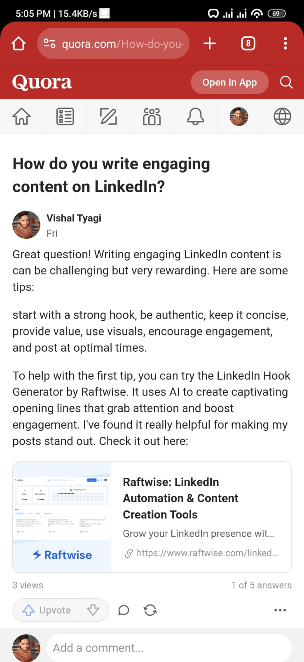

**Twitter**

* Comment - 1

Postlink - <https://x.com/tyagi81620/status/1817100309308576009>

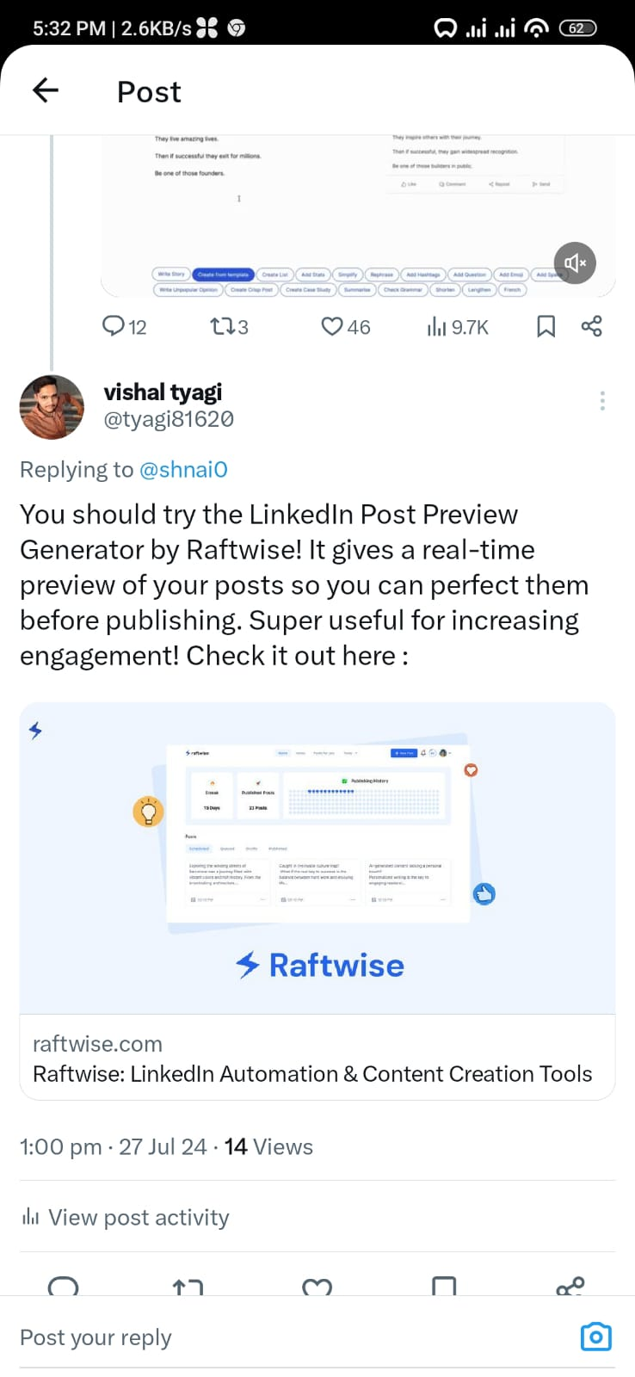

* Comment - 2

Postlink-<https://x.com/tyagi81620/status/1817098562427113642>

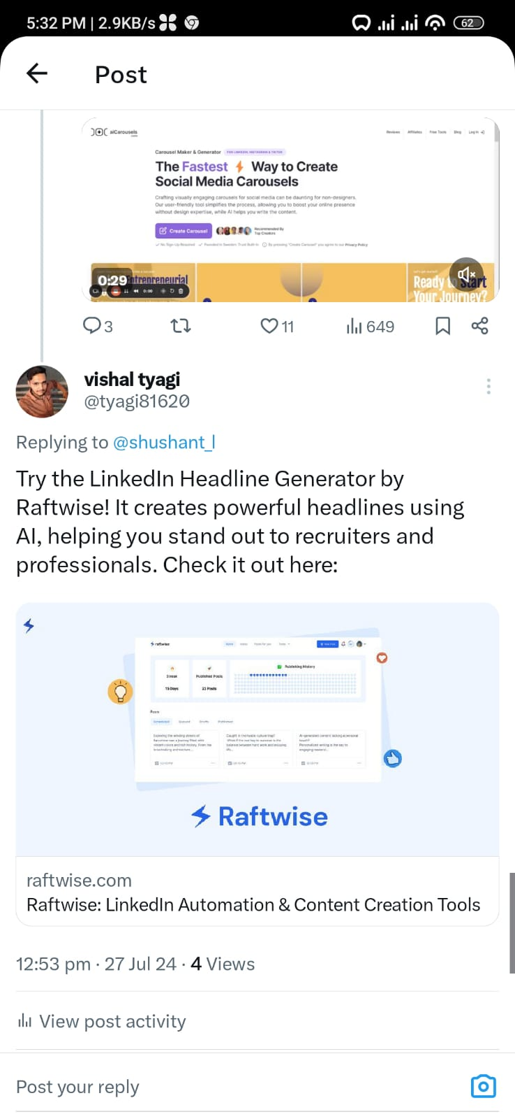

* Comment - 3

Postlink - <https://x.com/tyagi81620/status/1817096388158566503>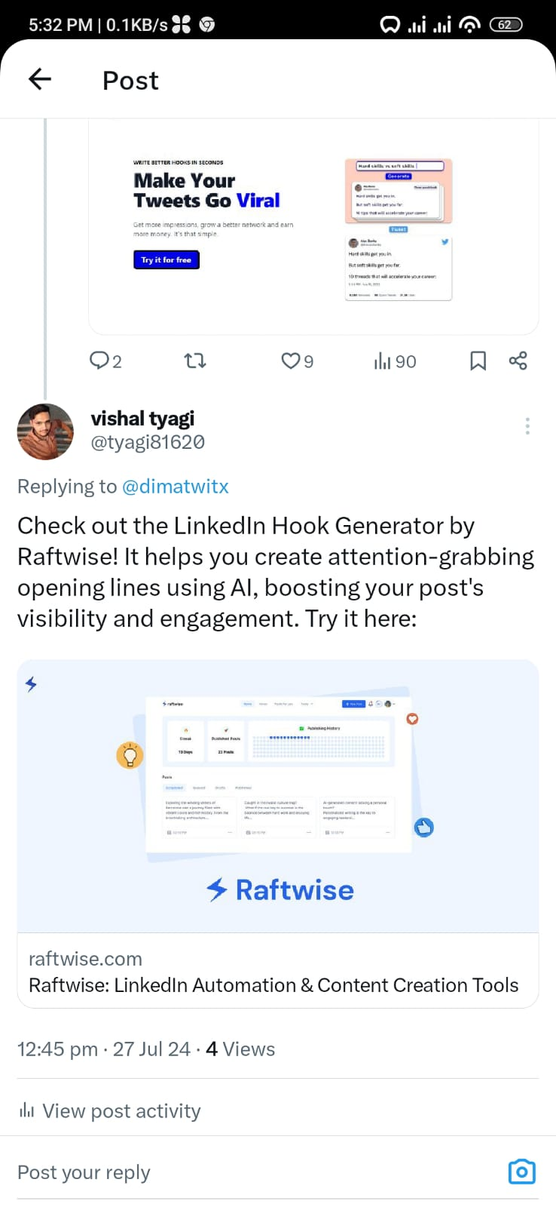

* Comment - 4

Postlink - <https://x.com/tyagi81620/status/1817088845189415342>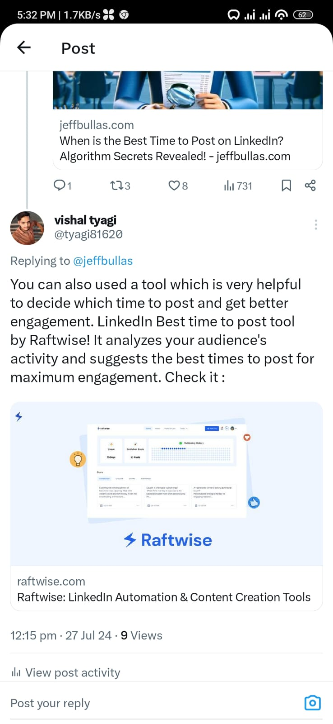

* Comment - 5

Postlink - <https://x.com/tyagi81620/status/1817085844177498272>

